Shabbos Stories for
Parshas mikeitz 5784
Volume 15, Issue 14 4 Teves 5784/December 16, 2023
Printed L’illuy nishmas Nechama bas R’ Noach, a”h
For a free subscription, please forward your request to keren18@juno.com
Past emails can be found on the website – ShabbosStories.com
When the Chazon Ish Drew a Brain Diagram for a Doctor

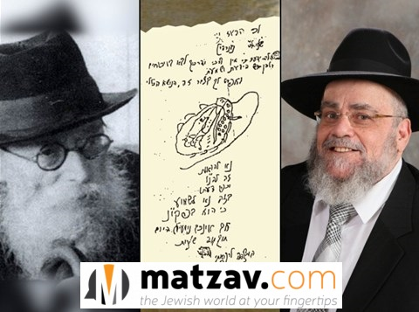

This week marks the first yahrtzeit of Rabbi Meir Shmuel Katz zt”l, who served as the menahel of Yeshiva Ohr Yisrael for many years. His family revealed how a sketch from the Chazon Ish guided a physician on how to perform a cranial surgery on their late father.
One of his sons recounted, “A few days before he passed away, my brother told him something about the Chazon Ish, and my father quietly said, ‘I, too, had something with the Chazon Ish.’ He then sealed his lips and said nothing more. During the shivah, a son of Rabbi Avraham Rein shared what he had heard from his father.
Rabbi Meir Shmuel Katz was born with excess fluid in his head, and doctors said that if he were to undergo surgery, he would die. Even if not, the chances were not high for him to survive. His mother traveled to the Chazon Ish together with Rabbi Rein, who was very close to the Chazon Ish. When they presented the case to him, the Chazon Ish said to proceed with the surgery. The doctor who heard this was visibly upset, questioning, “An old man who never studied medicine will give me advice?”
Following the mother’s pleas, the reluctant doctor traveled to Bnei Brak to meet with the Chazon Ish. During their meeting, the Chazon Ish drew on a page, illustrating the brain and how to perform the dissection, where to enter, and so on. (See below.) However, the doctor claimed that he was afraid to take responsibility for such a surgery. The Chazon Ish told him, “No one asked you to take responsibility. They asked you to perform the dissection.”

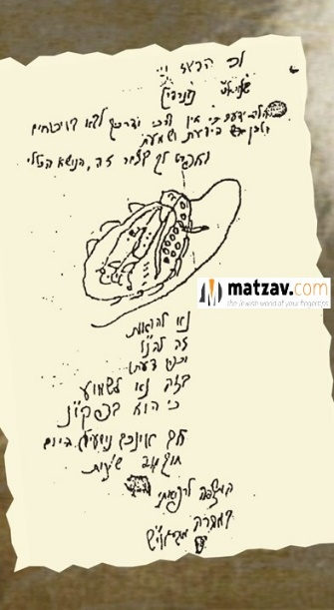

The surgery was carried out, and with the help of Hashem, Rabbi Katz lived another 75 years until his passing a year ago.
After the above story, the doctor became a follower of the Chazon Ish, consulting with him several times on additional surgeries. It is known that at least once, the Chazon Ish drew the surgical procedures for him. Rabbi Rein, who shared the story with the family, instructed Rabbi Schwartz not to have it revealed until after his passing.

Reprinted from the November 27, 2023 website of Matzav.com

The Lesson of the “Humiliated” Challos
By Rabbi Paysach J. Krohn

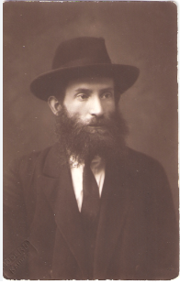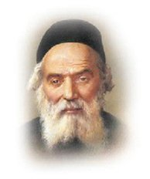
Rabbi Dovid Leibowitz (left) and the Chofetz Chaim

R’ Dovid Leibowitz, founder of Yeshivah Chofetz Chaim in New York, was molded in the Slabodka tradition of mussar. In one of his early mussar shmuessen, R’ Dovid depicted a scene that could occur in any Jewish home on any Friday night:
“Imagine a father and his children coming home from shul on Friday night. They walk into their home where they are greeted by the rest of the family. The table is bedecked with the glowing Shabbos candles and the sparkling wine which will soon be used for Kiddush. Everyone gathers around the table, ready to sing Shalom Aleichem.
However, as the father takes his place, he notices that the decorative challah cover is lying flat on the table before him. Someone – either his wife or one of the children – had forgotten to put out the challos! The father gets angry. ‘Who was supposed to bring the challos to the table?’ he snaps.
He then goes on to admonish sarcastically, ‘Is this the first time we have made Shabbos in this house?’ His wife is embarrassed, the children feel humiliated, and any guests present squirm in their places. But what the father does not realize is that the challah cover is beckoning to him with a message of great significance. The Mishnah Berurah (written by the Chofetz Chaim, who was R’ Dovid’s uncle) notes that we cover the challos בשתו הפת יראה שלא, so that the bread (challah) does not see its humiliation. Customarily, when one is about to eat a meal which will include both wine and bread, the blessing on the bread is made first. This is because in the Torah’s listing of the Seven Species, wheat is mentioned before grapes.
At the Shabbos table, though, because of the significance of making Kiddush on wine, the blessing on wine takes precedence over the blessing on challah. The challah, therefore, is covered so that ‘it does not observe its shame’ of being bypassed for the moment.
But in reality, does challah actually have sensitivities? Does it have feelings? Of course not! Yet Chazal instructed us to behave in a manner that conveys consideration and sensitivity to the challos. How much more important is it for us to show sensitivity to human beings who have feelings! Thus, the inconsiderate man, in denigrating his family members in the presence of the challah cover, is actually blind to what lies right in front of his eyes.”
The yahrzeit of R’ Dovid Leibowitz zt”l is on 15 Kislev (1941). May his merit protect us. (In the Footsteps of the Maggid)

Reprinted from the Parshas Vayishlach 5784 email of The Weekly Vort.

An Amazing Maggid
of Mezeritch Story
By Rabbi Sholom Dovber Avtzon

As is known there were many trade fairs in Europe that attracted sellers and buyers from numerous countries. One of these big fairs took place in Konigsberg, Germany. The author of Sippurim Noraim was there also and he rented a room in an inn that was used by many of the biggest sellers and buyers at the fair.
Among them were prominent businessmen from the city of Slutzk, who were also tremendous Talmidei Chachomim (Torah Scholars). While they discussed Torah thoughts, part of their conversation was also about Chassidim and their leaders. Each one had something to say.
The inhabitants of Slutzk were known to be staunch opponents of the Chassidic movement, and they spoke negatively about many of the Rabbonim of the chassidim. Then someone began to speak against the Maggid of Mezeritch.
To everyone's shock and bewilderment, the people of Slutzk interrupted the speaker and firmly stated, "It is forbidden to say anything negative, on such a miracle worker. While we are fierce opponents to the ways of chassidim and their leaders, however, what we witnessed with our own eyes, and not something that was related to us by others, cannot be denied.
The following astonishing and remarkable anecdote that he did, happened publicly in our own city.

The Lost Traveler Finds His
Way to the Town of Mezeritch
A member of our community traveled to the Vholin area for his business, however he lost his way and wandered aimlessly from around noon until midnight. He finally arrived in a town, which happened to be Mezeritch. Being that he was cold, he hoped to find a house where he could warm himself up, but as noted it was already midnight and everyone was asleep, as there was no light shining from any window.
Driving around the town he finally saw one house where the light was shining through the window, he drove over and knocked on the door. An individual opened the door, invited him in, and as he entered to warm himself up, he noticed that the light was coming from a different room. That room was the holy chamber of the Maggid.
Realizing that he had a guest in the house, the Maggid went over to him and greeted him with the traditional Sholom Aleichem. The Maggid then asked him, “From which city are you from?”
I am from Slutzk, the person replied. However, I wandered off the main road and I got lost until I finally noticed this town,

The Reason for Why You Strayed Off the Path
Everything is b'hashgacha protis, (Divine personal providence), the Maggid said to him. Therefore, it wasn't for naught that you strayed off the path and ended up at my house. There is a reason for it!!
The Maggid then put on his glasses, (this was his mode of conduct whenever he wanted to limit his vision to see only one thing (and not the entire world,) and momentarily looked at the guest.
The Maggid then said, "When you left your house, your son was gravely ill.
That is correct, the guest replied.
You have nothing to worry about, continued the Maggid, as Boruch Hashem, your son is now in excellent health.
When you return home, you will find the entire city in an uproar, as many, many young children are passing away, while your son had healed and became healthy. The Rov and the judges are searching and trying to find out what is the grave sin that is causing [Hashem's displeasure to make] numerous young children to pass away.
The day after you return one of the magnates will be celebrating the birth of his newborn son, and he will prepare a large meal in honor of it. He will invite you to be one of the attendees.
All the important people of the city will also be attending, and the conversation would be about the horrible plague that is killing so many infants. They will come to the conclusion that a certain individual is the sinner; however, he is pure and innocent from doing any sin Chas V'sholom (G-d Forbid).
One of very honored guests will be a wealthy magnate, one of the leaders of the city, and he happens to be a tremendous sinner. His actions are causing the deaths of the infants.

An Obligation to Accuse the Wicked Man
After the other guests will come to their conclusion about this innocent person that he is the sinner, they will begin hitting him, imploring him to admit to his misdeeds and repent. The above-mentioned magnate will attempt to join them. However, when he raises his hand to hit that individual, you are to grab his hand and say firmly to the magnate, "Wicked one, you are the one to admit, as you are the grievous sinner!" It is because of you that so many of our young children have passed away.
He will immediately admit, and the plague will immediately stop, Not one more child will die.
The Maggid concluded, "If you don't do as I instructed you, you should know that your own son, will immediately die an unpleasant death.

The Man Left Out Not One Detail from the Maggid’s Instructions
The businessman went home, and he fulfilled everything that the Maggid instructed him to do. There was not one detail which the Maggid said to him would happen that didn't occur.
All the inhabitants of Slutzk were astonished from this wonderous happening,
The businessmen from Slutzk then said to the others who were together with them at the fair, "Would you find such a holy person that the spirit of Hashem is in with him? We all witness this, and it is impossible to deny it.

Reprinted from the Parshas Vayeitzei 5784 email of the Weekly Story of Rabbi Sholom Avtzon.

A Gift of Life
By Rabbi Yosef Weiss

In the year 1928, the entire Jewish world was horrified to hear that the saintly Hafess Hayim, at the age of eighty-eight, was terribly ill. All around the globe, prayers streamed heavenward as Klal Yisrael begged Hashem to spare the Hafess Hayim and allow him to recuperate and receive a complete refuah shelemah.
One young man of twenty-three, who lived next door to the Hafess Hayim was particularly distressed. R' Mordechai had long since cherished the unique opportunity to attend to the Hafess Hayim and fulfill his every need. Now, his beloved Rabbi was close to death. How could Klal Yisrael survive without the Hafess Hayim's guiding hand?

A Special Night Spent in the Bet Midrash
One evening, R' Mordechai entered the bet midrash and spent the entire night engrossed in the recital of Tehillim, tears streaming down his cheeks as he fervently prayed to Hashem for the Hafess Hayim's recovery. By morning R' Mordechai was still hunched over his Tehillim in the deserted bet midrash, immersed in earnest prayer.
Seeing that the bet midrash was empty, he hesitated for a moment, then slowly approached the aron hakodesh. He felt that he must do more than just pray for the Hafess Hayim. Now, with nobody else to witness what he was about to do, he opened the aron hakodesh and lovingly kissed the sifrei Torah.
"Ribbono Shel Olam," he whispered, "Klal Yisrael needs the Hafess Hayim. I am thereby giving up five years of my life for him so he should have a speedy recovery."

Didn’t Anyone to Know What He Had Done
Without another word, R' Mordechai closed the aron and returned to his seat. People would soon be coming, and he did not want anyone to know what he had done.
Days later, the news raced through Radin. The Hafess Hayim was recuperating! The danger was past! Within a few weeks, the Hafess Hayim had fully recovered .
R' Mordechai happily looked forward to resuming his holy duties for the Hafess Hayim, but a nagging thought troubled him. He had granted five years of his life to his beloved Rabbi, but he was only a young man in his early twenties. What good could five of his years be for a gadol of the Hafess Hayim's stature? Perhaps someone on a higher level would be required to donate years for the Hafess Hayim. On the other hand, if the value of the years would be measured by the level of the recipient, there would be no problem. R' Mordechai would have given his Rabbi five years which the Hafess Hayim could use at his own sublime level. But how could he know which theory was correct?

Wanted to Ask the Tzadik a “Theoretical Question”
He decided to approach the Hafess Hayim and ask him a "theoretical question." As R' Mordechai approached the Hafess Hayim's desk, the gadol gazed steadily at him and said, "Mordche, you should know that your prayers were accepted in heaven."
At first, R' Mordechai assumed that the Hafess Hayim referred to his prayers which, like those of all Klal Yisrael, had been dedicated to the gadol's recovery. But the Hafess Hayim continued, "I will give you my word, Mordche, that in the merit of what you have given me, you will live to be as old as I am now."
R' Mordechai stared at his Rabbi in shock. How had he known of the offer he had made to Hashem several weeks ago?

The Hafess Hayim Lived Another Five Years
The Hafess Hayim lived for five more fruitful years, before his passing in 1933 at the age of ninety-three. R' Mordechai Londinski never breathed a word about the incident that had taken place, although he did relate the story to his oldest son, Moshe.
In Sivan of 1995, when he had just turned eighty-nine, R' Mordechai passed away. He was one year older than the Hafess Hayim had been during his near-fatal illness.
At R' Mordechai's funeral, R' Moshe Londinski repeated his father's story for the first time, then added, "My father would have wanted this story to be told for only one reason: to show the world more of the holiness of the Hafess Hayim.(Visions of Greatness II

Reprinted from the Parshat Vayesse 5784 email of Rabbi David Bibi’s Shabbat Shalom from Cyberspace.

A Shliach Tzibbur
By Rabbi Paysach J. Krohn

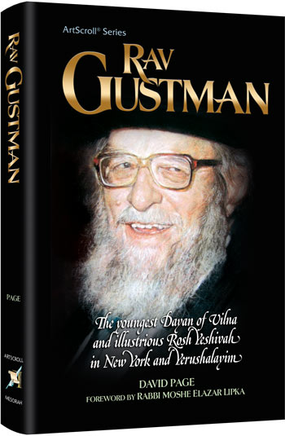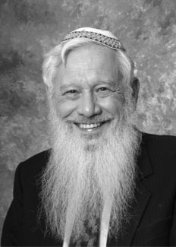
Professor Yisroel (Robert Aumann)

Rav Yisroel Zev Gustman zt”l was a brilliant Torah giant of the previous generation, so much so that he was appointed by Rav Chaim Ozer Grodzinski zt”l—the gadol hador in Vilna in the early 1900s—as a dayan (judge) in his early twenties.
But unfortunately, Rav Gustman suffered terrible times in Vilna. He did indeed survive the Holocaust with his wife and daughter, but he was not without his sorrows.

Established the Yeshiva Netzach Yisroel
After Rav Gustman came to America and then later to Israel and established in both countries the yeshiva Netzach Yisrael, the following took place.
Every day he would give a shiur (lecture) specifically to students, though each Thursday he gave a shiur which was open to the public. The audience was comprised of an eclectic bunch, including mathematicians, scientists, professors and judges. One of the attendees was a well-known figure, Professor Robert Aumann, a Nobel Prize winner in Economics in 2005. He was very fond of Rav Gustman, and Rav Gustman was equally fond of him as well.
Tragically, in June 1982, Israel was involved in a war with Lebanon. Professor Aumann had a son, Shlomo, who was a lecturer in a yeshiva in Jerusalem. Shlomo himself had a young child, and his wife was expecting their second. During that war, Shlomo was called up to serve in the army and lost his life. He never had the opportunity to see the birth of his second child—a son who was born soon thereafter.

Led His Entire Yeshiva to Attend the Funeral of Shlomo
Of course, it was heartbreaking. Rav Gustman, hearing this news, had his entire yeshiva attend the funeral of Shlomo, who was buried in a cemetery reserved for Israeli soldiers. After the funeral, Rav Gustman headed to the area where other Jewish soldiers were buried and broke down himself in tears. “Every one of them is holy,” he remarked.
Professor Aumann then returned to his home to begin sitting shiva. But within mere hours, Rav Gustman showed up. Noticing this, Professor Aumann asked why Rav Gustman hadn’t yet returned to his students at the yeshiva. He had already made the trip to attend the funeral; wouldn’t it make more sense for him to return to pay a shiva call a different day?
“No,” replied Rav Gustman. “I want to be here. I want to sit next to you.” Rav Gustman then retold a story that had transpired years before.
“When the Germans entered Vilna, they caught me one day holding my son. He was my little boy, named Meir. But, with complete disregard, the Germans grabbed him out of my hands and shot him and killed him right before my eyes.
“We were so hungry and so starving that I needed to take my son’s shoes and barter them for food. But to tell you the truth, I could never eat that food because I knew I had exchanged my child’s shoes for it.
“I must tell you I never had the opportunity to sit shiva for Meir. So, I would like to sit shiva now, here, with you.

“He Died Only Because He was a Jew”
“My son is in the highest places in Heaven right now. He died only because he was a Jew, and he is a kadosh, just as are all other Jews whose lives were snuffed out because they were Jewish.
“But your son died defending Jewish people, and in that sense, he is like a shliach tzibuur (leader of the congregation), and he is on a different level. Your son represented the Jewish nation and protected and defended them with his very life. My son was never able to do that, but your son did. And that makes your son very, very special.”
Professor Aumann looked up at Rav Gustman with tears in his eyes. “Rebbe, I never thought that I could be comforted for the loss of my child. But you comforted me.”
Every single Jewish soldier is a shliach tzibbur because he or she is protecting and defending the Jewish nation.
May Hashem, measure for measure, protect them all.

Reprinted from the Parashat Vayetzei edition of the Torahanytime Newsletter compiled and edited by Elan Perchik.

A Few Dollars
Reaching Heaven
By Mr. Charlie Harary

A friend of mine was working on collecting army gear for Jewish soldiers. Many of our soldiers didn’t have as much equipment as they needed, and when word got out that such an endeavor could support the army, my friend began shouldering the responsibility of seeing it through as best as he could.
One Friday afternoon, he was sitting at his home office, coordinating the various components that would land more gear in the hands of our Jewish brothers and sisters on the front lines. As this was going on, a thought crossed his mind about his nine-year-old son. Most Friday afternoons, he would get together with his friends and play for a bit. And usually, at some point of their get-together, they would come knocking on his office door and say hello. But that afternoon, it seemed quieter than usual. His son wasn’t out and about like he usually was. Where was he though?
Looking around, he found him. He was trudging out to the backyard, then into the house, then out onto the front lawn. But it didn’t end there. Back he went into the house to the refrigerator, grabbing some sodas and ice teas (some of which seemed like he made) and then back out front. Scotch tape followed, along with some markers and paper. Some noise accompanied the process, all to the father’s remaining uncertainty of what exactly was going on.

His Son Lined Up Sodas and Ice Teas
for Sale Right in Front of the House
And then it came into plain sight. His son had lined up sodas and ice teas for sale right in front of the house. But why? And would anything come of it?
A few minutes later, a car pulled up to the front, and a guy rolled down the window and stuck his hand out. The boy ran around to the passenger window and grabbed what was a five-dollar bill in exchange for some drinks. “Keep the change,” said the driver.
Minutes later, another window came rolling down. “Hey, what are you doing?” “I’m raising money for Israel.” “What?” came the surprised reply. “How much for a drink?” “Fifty cents.” “Here’s a ten—keep the change.” Another neighbor soon walked by. “What are you doing?” “I’m raising money for Israel.” A minute later, the neighbor came out of his house with a box of cookies. “Raise these too,” he said.
The father, looking out at his son and all his sodas and box of cookies, watched as kid after kid and car after car went by. After a couple of hours, the boy bid his friends goodbye and headed inside.
And then came the knock at his office door. “Daddy, I hear you’re raising money for Israel. Here’s $78.50. Can you send it to them as well from me?”
When I first heard this, I was moved beyond words.

Similar to Our Relationship with Hashem
In many ways, this story is representative of how our relationship is with Hashem. We would make a mistake to think that we do chesed because Hashem needs it. Hashem doesn’t need it; He can do whatever He wants. If He wants blessing, success and abundance to be showered upon the Jewish nation, it’s not difficult for Him. It’s only a second away until He grants it to us. And equally so, we are the little nine-year-old boy relative to Hashem.
I can almost imagine the nachas (pleasure) Hashem gets when we go out of our way to raise money and help our Jewish brothers and sisters. To Hashem, Who can do anything, any human contribution is akin to a couple of cents. But when we help each other and do for one another, despite Hashem having all the means and resources to do anything, it still gives Him unbelievable nachas. You can just imagine how the father felt seeing his nine-year-old son commit and dedicate himself to helping our brothers and sisters. Hashem feels much the same way.
When we do anything, even raising just a few dollars for another Jew, it echoes in the Heavens and brings true pride and delight to our Father in Heaven.

Reprinted from the Parashat Vayetzei edition of the Torahanytime Newsletter compiled and edited by Elan Perchik.

The Fire Fighter:
One Miraculous
Tale Leads to Another
By Nissan Mindel

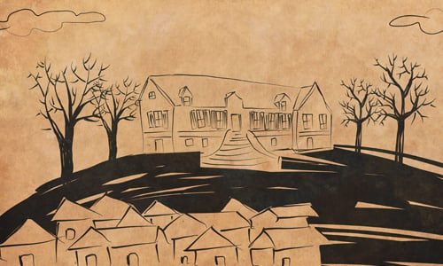
Art by Sefira Lightstone

Once, Rabbi Schneur Zalman of Liadi, known as the Alter Rebbe, came to a small town. During his short stay in that town, a fire broke out in one of the wooden houses. The local firemen had a hard time keeping the fire under control, and soldiers from a garrison stationed nearby came to help extinguish it. But a strong wind fanned the flames and sparks were flying in the air, threatening to set the whole town ablaze.
Several worried townspeople came to the saintly Rebbe and told him of the danger. Rabbi Schneur Zalman asked to be shown where the fire was, and he was led to the blazing house. He stood there for a few moments, leaning on his walking cane, and gazing intensely at the blaze.
Suddenly, the wind stopped and the fire began to subside. Within a few moments the fire was brought under control, and everybody breathed a sigh of relief. The town was saved! Everybody talked excitedly about the wonderful miracle which was brought about by the saintly Rebbe.

The General was Told of the
Saintly Rebbe’s Wonderful Miracle
The soldiers returning to their barracks told their general of the miracle that the saintly Rabbi performed before their very eyes. The general sent his orderly to ask the Rabbi to appear before him.
The general greeted Rabbi Schneur Zalman with respect and reverence. "Are you, perhaps, a son or a grandson of the saintly Rabbi Israel Baal Shem Tov?" the general asked him.
"I am indeed his "grandson," but in a spiritual sense, for I am a disciple of his disciple," the Alter Rebbe replied.
"Well, then I was not wrong in my conclusion, and I am not at all surprised that you should have supernatural power." Saying this, the general brought out a leather-bound volume, and pointing to it, he continued:

The Master of the Good Name
"Let me tell you a wonderful thing that happened to my late father, which he recorded here in his diary. It happened when my father was stationed with his troops near the town of Mezhibozh. He had received no word from his wife for a long time, and he was very worried. Seeing how troubled the general was, some of his friends said to him: 'There lives in this town a saintly Rabbi, who is known as the Master of the Good Name. People tell wonderful things about him, and say that there is nothing hidden from him. Why not go and see this saintly man?'
"My father, the general, decided that there was nothing he could lose by seeing that saintly man, and he sent his orderly to the Baal Shem Tov to arrange a time to visit him.
"The orderly returned and told my father that the Baal Shem Tov said he was too busy. This infuriated my father. He sent the orderly back again to the Baal Shem Tov to tell him that if he refused to see him, he (my father) would billet his soldiers in the Jewish houses, and there would not be a single Jewish home which would not have to provide food and lodging for one or more soldiers.
"This threat was very serious, for not only were the Jews of the town poor and unable to afford the burden, but it was also close to the Jewish festival of Passover, and the soldiers would bring chometz into the Jewish homes! But when the orderly returned, he brought the answer that although the saintly Rabbi is too busy, a time had nevertheless been fixed for my father's visit!

A Strange Sight Unfolded Before His Eyes
"Promptly at the appointed time, my father and his orderly came to the house of the Baal Shem Tov. Through an open door leading from the living room, they saw the saintly Baal Shem Tov sitting in his study, his head bent over a book. By force of habit, my father went up to a small mirror hanging on the wall to smooth his hair. As he looked into the mirror, a strange sight unfolded before his eyes.
Instead of seeing a reflection of his own face, he saw a familiar road, the road leading to his own home town. Not believing his eyes, and thinking that his imagination was playing tricks on him, he called his orderly to the mirror. The orderly was no less amazed. Presently, the road seemed to pass by them, and they found themselves on the familiar street where the general lived.
The door of the house opened and my father saw his wife sitting at her desk writing a letter. As if looking over her shoulder, they saw that she was writing a letter to him! In it she begged him to excuse her for not writing for so long, for she was occupied with the pregnancy and birth of his new child-a boy! Both she and the baby are fine, and she longed for him to come home and see his son!

The Same Letter that He Miraculously
Saw in the Baal Shem Tov’s Mirror
"You can imagine how excited my father became. Forgetting where he was, he rushed back to his quarters, and there, on his desk, was a letter for him from his wife. He opened it and read it over again and again. It was exactly what he had seen in the mirror in the Baal Shem Tov's house!
"I am that baby about whom my mother wrote to my father in that letter!
You can see the whole story recorded by my father in his diary."
Concluding his amazing story, the general asked the saintly Rebbe to bless him.
"Be good to the Jews, and the Almighty will bless you," the Rebbe replied, "for so it is written in the Torah: 'They that bless you [Abraham] shall be blessed.'"

Reprinted from the Parshat Vayishlach 5784 website of Chabad.org Excerpted from the book “The Story Teller.”

